**Use Case Documentation**

The use case diagram is usually a graphical description of interactions between the elements of a system. This is also a methodology which is used in system analysis to identify, organize and clarify the requirements of the system.

**Purpose:**

The main functionality of the use case diagram is to show in what way a user can communicate with the system, this may help in developing a prototype of the system and identifying specific requirements for that particular task. A use case diagram is similar to that of a flow chart. A use case diagram mainly consists of four basic components, they are

**Actor:** Individuals who are involved in the system, defined as per their roles.

**Use Cases:** these are said to be the specific roles played by the actors within the system or around the system.

**Boundary:** This defines the system of interest in relation with the world which is around that particular system.

**Relationships:** These are the specific relation between the actors and the use cases of the system.

A use case diagram generally consists of an actor and all the task which can be performed by the actor which are represented in the form of an oval called use cases.

In the proposed system there are mainly three actors around which the complete system is based up on they are Student and Instructor.

**Student:**

This actor plays a major role in the system. He is responsible for login in to the system using his Student ID as his user name and using his unique password with all the constraints. He then scans the QR and captures an image of the QR and then sends it to the instructor for grading his attendance. He can also view the overall courses he is registered in to and also check the individual percentage in each of his course. He receives a feedback as soon as the code is captured and is sent to the instructor for grades.

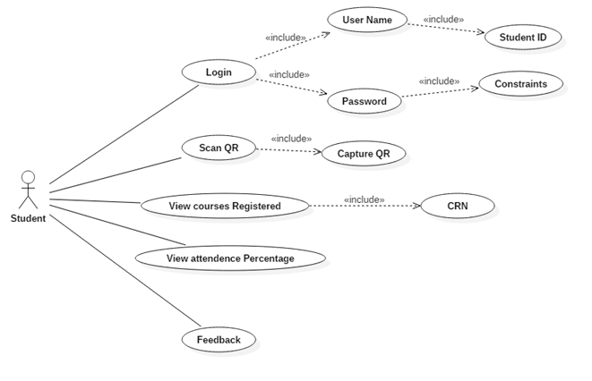

**Use Case Diagram for Student**

Login Successful

In the initial stage the student must login with his User Name and Password. Username of the student is his SID and Password has few Constraints. Once logged in the student will get a popup as login successful. In the student view once they logged in they can see three modules like Scan QR, View Courses Registered and view attendance percentage.

Login unsuccessful

In the initial stage if the student enters wrong username or wrong password they will get a popup as login unsuccessful

Scanning QR

In the scan QR module Student can Scan QR code with his Web mobile application and later he must capture the QR code for security purpose. After Capturing QR the student gets a popup as Scan Successful

View Course Details

In the view courses registered module students can view their courses which they have been registered for that semester. Within that module they can view Timings of the class, CRN and Instructor Name of that course.

Attendance Percentage and feedback

In the view attendance percentage module students can view their attendance percentage and students will receive feedback after scanning and capturing the QR like Scan Successful, Scan Unsuccessful and Capture Unsuccessful.

**Instructor:**

This actor is capable of managing the student and his attendance. He is also capable of updating the attendance details of the student. He has many vital roles such as managing the courses, managing the students, and displaying the QR codes. In the process of managing the student instructor is capable of viewing the details of the students and also check the percentage of the student and update it. In the process of managing the courses he is able to add or delete the courses with his own sections. He is also allowed to display the QR codes according to the time at which the class meets and the CRN number and he also has an access to generate multiple QR codes based on his requirements for a specific class at any point of time.

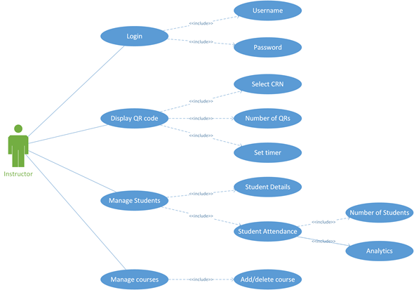

**Use case diagram for Instructor**